Professora: Mirela Vanina
Tutor: Jairo Amaral

Lista 1

- Apenas “c” e “d” representam gráficos de funções, pois cada valor no domínio tem somente um valor na imagem.

  - $g\left(0\right)=0$; $g\left(2\right)=2/3$; $g\left(\sqrt{2}\right)=\sqrt{2}$; $g\left(-1\right)∄$.
  - $3$.
  - $h\left(-1\right)=3$; $h\left(1/2\right)=-1/2$; $h\left(2/3\right)=-2/3$.

  - $A=0$.
  - $A=\frac{x^{3}-p^{3}}{x-p}=x^{2}+px+p^{2}$.
  - $A=\frac{\frac{1}{x^{2}}-\frac{1}{9}}{x+3}=-\frac{x-3}{9x^{2}}$.

  - $6\left(x^{2}+xh-x\right)-3h+2h^{2}+4$.
  - $\frac{1}{x^{2}+10x+xh+5h+25}$.
  - $0$.
- A
  - ${Dom}_{f}=\left\{x∈R|\left|x\right|≠1\right\}$;
  - ${Dom}_{f}=\left\{x∈R|x≠-2\right\}$;
  - ${Dom}_{f}=\left\{x∈R|\left|x\right|≠2\right\}$;
  - ${Dom}_{f}=\left\{x∈R|x≤0\right\}$;
  - ${Dom}_{f}=\left\{x∈R|\left(x≤-1\right) ou (0≤x≤1)\right\}$;
  - ${Dom}_{f}=\left\{x∈R|x≥-1\right\}$;
  - ${Dom}_{f}=R$;
  - ${Dom}_{f}=\left\{x∈R|\left|x\right|≥\sqrt{2}\right\}$;
  - ${Dom}_{f}=\left\{x∈R|-1≤x≤2\right\}$;
  - ${Dom}_{f}=\left\{x∈R|\left(x≥1\right) ou (x<-1)\right\}$;
  - ${Dom}_{f}=\left\{x∈R|1/3<x≤1/2\right\}$;
  - ${Dom}_{f}=\left\{x∈R|\left(x<-3\right)ou (x≥0)\right\}$;
  - ${Dom}_{f}=\left\{x∈R|\left|x\right|>1\right\}$;
  - ${Dom}_{f}=\left\{x∈R|\left(\left|x\right|≠1\right) e \left(x≠0\right) e (x≤4/3)\right\}$;
  - ${Dom}_{f}=\left\{x∈R|-1<x<1\right\}$;
  - ${Dom}_{f}=\left\{x∈R|-2<x<2\right\}$;
  - ${Dom}_{f}=\left\{x∈R|\left(-1<x≤1\right) ou (x≥2)\right\}$;
  - ${Dom}_{f}=\left\{x∈R|x≠kπ,k∈Z\right\}$;
  - ${Dom}_{f}=\left\{x∈R|kπ≤x≤\frac{π}{2}+kπ,k=0,1,2,…\right\}$;
  - ${Dom}_{f}=\left\{x∈R|x≠kπ,k∈Z\right\}$;
  - ${Dom}_{f}=\left\{x∈R|x≠kπ,k∈Z\right\}$.

  - ${Dom}_{f}=\left\{x∈R|x≠0\right\};{ Im}_{f}=R-\{0\}$;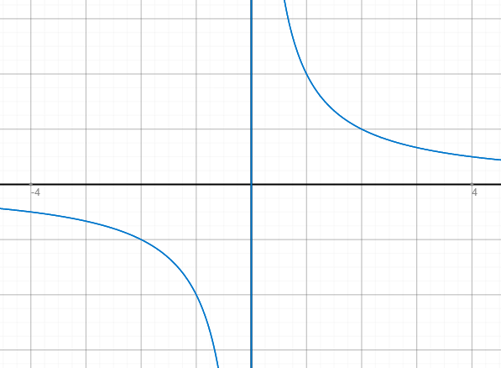
  - ${Dom}_{f}=\left\{x∈R|x≥-2\right\}$;${Im}_{f}=R_{+}$; 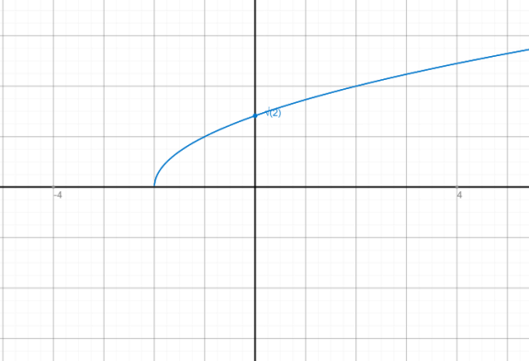
  - ${Dom}_{f}=\left\{x∈R|x≠-1\right\}$;${Im}_{f}=R-\{0\}$ 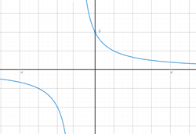
  - ${Dom}_{f}=R; {Im}_{f}=R$;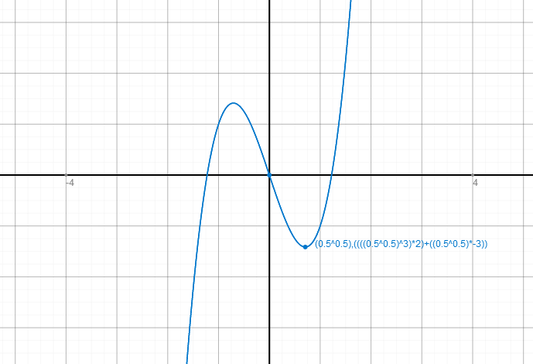
  - ${Dom}_{f}=\left\{x∈R|x≠0\right\}$;${Im}_{f}=R-\{1\}$;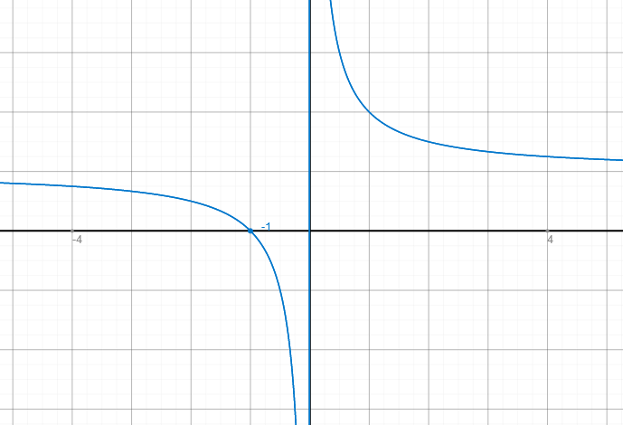
  - ${Dom}_{f}=R$;${Im}_{f}=R_{+}^{*}$;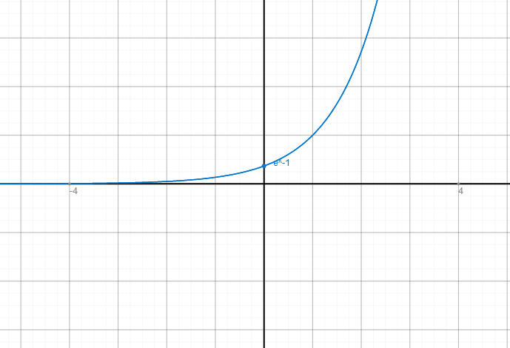
  - ${Dom}_{f}=R$ ; ${Im}_{f}=[-1,+∞)$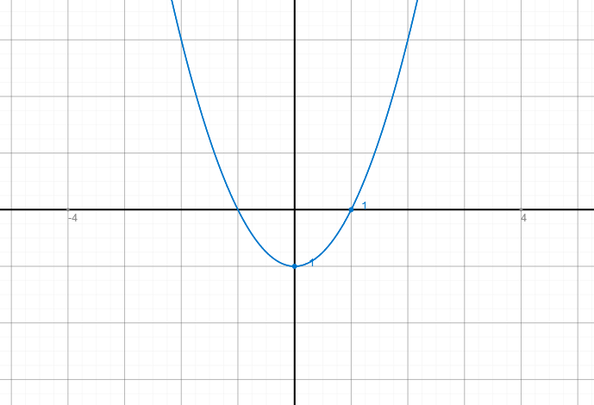
  - ${Dom}_{f}=R_{+}^{*}$;${Im}_{f}=R$;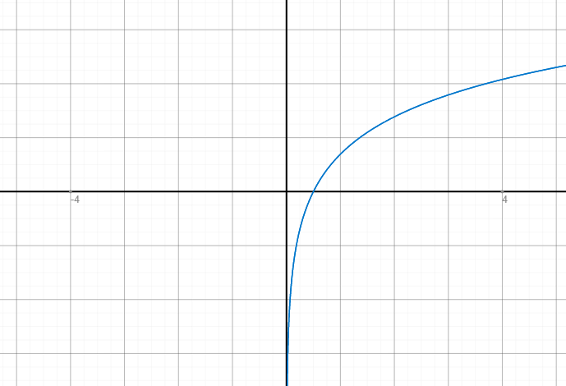
  - ${Dom}_{f}=R$; ${Im}_{f}=(-∞,-2]$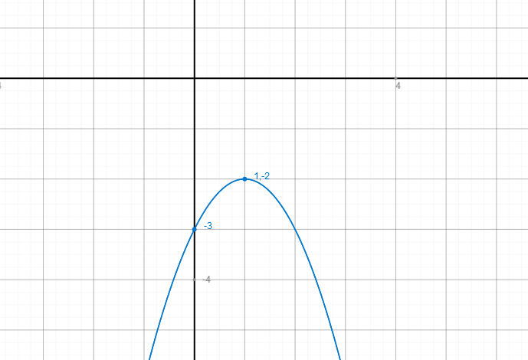
  - ${Dom}_{f}=R$;${Im}_{f}=[-1,1]$;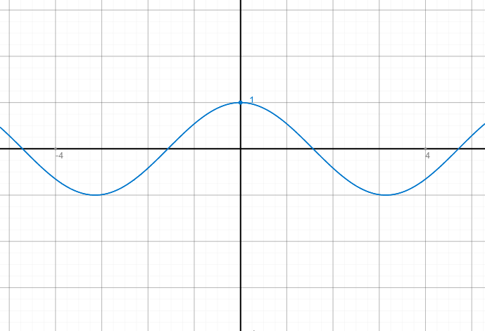
  - ${Dom}_{f}=\left\{x∈R|x≠-3\right\}$;${Im}_{f}=R-\{-6\}$;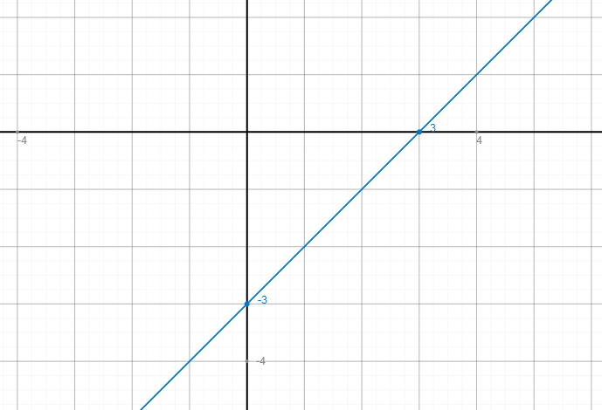
  - ${Dom}_{f}=R$;${Im}_{f}=[-2,2]$;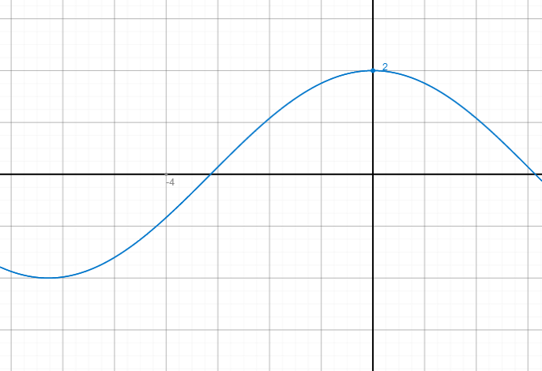
  - ${Dom}_{f}=R$;${Im}_{f}=\left\{0\right\}∪\{1\}$;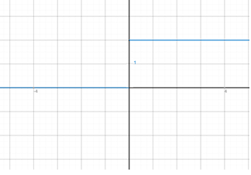
  - ${Dom}_{f}=R; {Im}_{f}=(-∞,2]∪\{30\}$; 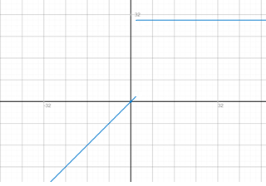
  - ${Dom}_{f}=R$;${Im}_{f}=R_{+}$;
  - ${Dom}_{f}=R$;${ Im}_{f}=R$;
  - ${Dom}_{f}=R$; ${Im}_{f}=R$;
  - ${Dom}_{f}=R$;${Im}_{f}=(-1,+∞)$; 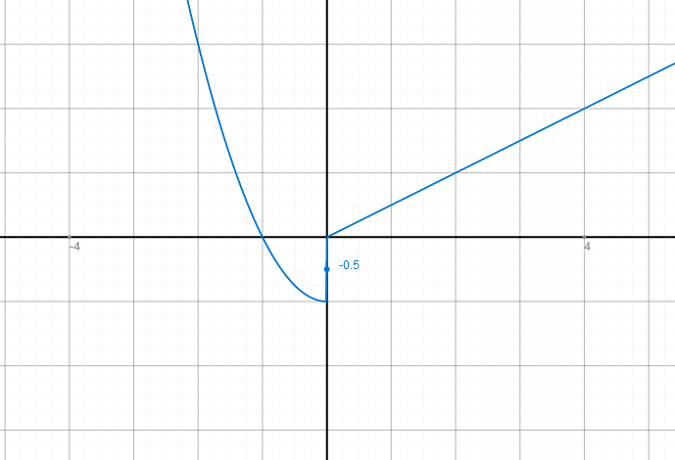
- $f\left(1/2\right)=0$;$f\left(5/4\right)=1$;$f\left(-1/5\right)=-1$.
${Dom}_{f}=R;$ ${ Im}_{f}=Z$.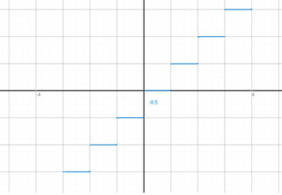
- Nota: é difícil estabelecer os valores exatos da imagem de algumas funções sem usar derivadas.
- $D_{f}=R;$ $I_{f}=R$;$D_{g}=R$;$I_{g}=(-1,∞)$;
$f+g=x^{2}+x-6$;$D_{f+g}=R; I_{f+g}=(-6,25,+∞)$.
$f∙g=x^{3}-5x^{2}-x+5$;$D_{f.g}=R; I_{f.g}=R$.
$f/g=\frac{x-5}{x^{2}-1}$; $D_{f/g}=\left\{x∈R|\left|x\right|≠1\right\}$; $I_{f.g}≈(-∞, 0.05)∪( 4.95,+∞)$
$g/f=\frac{x^{2}-1}{x-5}$;$D_{g/f}=\left\{x∈R|x≠5\right\}; I_{g/f}≈(-∞,0.2)∪(19.80,+∞)$.
- $D_{f}=\left\{x∈R|x≠1\right\};$ $I_{f}=R-\{1\}$;$D_{g}=\left\{x∈R|x≠0\right\}$;$I_{g}=R_{}^{*}$;
$f+g=\frac{x^{2}+2x-1}{x^{2}-x}$;$D_{f+g}=\left\{x∈R|x≠1 e x≠0 \right\}$; $I_{f+g}=R$;
$f∙g=\frac{x+1}{x^{2}-x}$;$D_{f.g}=\left\{x∈R|x≠1 e x≠0 \right\}$;$I_{f.g}≈(-∞,-5.82)∪(-0.17,+∞)$;
$f/g=\frac{x^{2}+x}{x-1}$;$D_{f/g}=\left\{x∈R|x≠1\right\}$;$I_{f/g}≈(-∞,0.17)∪(5.82,+∞)$;;
$g/f=\frac{x-1}{x^{2}+x}$;$D_{g/f}=\left\{x∈R|x≠-1 e x≠0 \right\}$;$I_{g/f}≈(-∞,0.17)∪(5.82,+∞)$;
- $D_{f}=\left\{x∈R|x≥0\right\}; I_{f}=R_{+}$;$D_{g}=R$;$I_{g}=\left[-1,+∞\right)$
$f+g=x^{2}+\sqrt{x}-1$;$D_{f+g}=\left\{x∈R|x≥0\right\}$;$I_{f+g}=(-1,+∞)$;
$f∙g=\sqrt{x}\left(x^{2}-1\right)$;$D_{f.g}=\left\{x∈R|x≥0\right\}$;$I_{f.g}≈(-0.53,+∞)$
$f/g=\frac{\sqrt{x}}{x^{2}-1}$;$D_{f/g}=\left\{x∈R|\left(x≥0\right)e\left(|x|≠1\right)\right\}$;$I_{f/g}=R$;
$g/f=\frac{x^{2}-1}{\sqrt{x}}$;$D_{g/f}=\left\{x∈R|x>0\right\}$;$I_{g/f}=R$.
- $D_{f}=R$;$I_{f}=R_{+}$;$D_{g}=\left\{x∈R|x>0\right\}$;$I_{g}=(0,+∞)$.
$f+g=x^{2}+\frac{1}{\sqrt{x} }$; $D_{f+g}=\left\{x∈R|x>0\right\}$;$I_{f+g}=(1.65,+∞)$;
$f∙g=\frac{x^{2}}{\sqrt{x}}$;$D_{f.g}=\left\{x∈R|x>0\right\}$;$I_{f.g}=(0,+∞)$;
$f/g=x^{2}\sqrt{x}$;$D_{f/g}=\left\{x∈R|x≥0\right\}$;$I_{f/g}=[0,+∞)$;
$g/f=\frac{1}{x^{2}\sqrt{x}}$;$D_{g/f}=\left\{x∈R|x>0\right\}$;$I_{g/f}=(0,+∞)$.

    - Ambas são bem definidas. $(f∘g)\left(x\right)=x^{2}-6$;$( g∘f)\left(x\right)=x^{2}-10x+24$.
    - $f∘g$: A={$x∈R-\{0\}|g(x)≠1$}={$x∈R|x≠0 e x≠1$}
$(f∘g)\left(x\right)=\frac{x+1}{1-x}$;
$(g∘f)$:$B=\left\{x∈R-\left\{1\right\}\left|f\left(x\right)≠0\right\}=\{x∈R|x≠1 e x≠-1\}\right\}$; $(g∘f)\left(x\right)=\frac{x-1}{x+1}$.
    - $f∘g$ : A={$x∈R|g(x)≥0$}={$x∈R|x≤-1 ou x≥1$}; $(f∘g)\left(x\right)=\sqrt{x^{2}-1}$
$g∘f$ : bem definida;$(g∘f)\left(x\right)=x-1$.
    - $f∘g$: bem definida.$(f∘g)\left(x\right)=1/x$;
$g∘f$: B$=\left\{x∈R|f\left(x\right)>0\right\}=\left\{x∈R|x≠0\right\}$.$(g∘f)\left(x\right)=1/|x|$.
  - $f∘g$:bem definida.$(f∘g)\left(x\right)=\frac{1}{x^{2}}-1$;
$g∘f:\left\{x∈R|f(x)≠0\right\}=\left\{x∈R||x|≠1\right\}$. $(g∘f)\left(x\right)=\frac{1}{x^{2}-1}$.
  - $f∘g$:$A=\left\{x∈R-\{0\}|g(x)≥0\right\}=\left\{x∈R|x<0\right\}$.$\left(f∘g\right)\left(x\right)=\frac{1}{\sqrt{-x}}$
$g∘f$:$B=\left\{x∈R_{+}|f(x)≠0\right\}=\left\{x∈R|x>0\right\}$ ;$(g∘f)\left(x\right)=-\frac{1}{\sqrt{x}}$.
- Não, porque $f\left(x\right)$ tem domínio $D_{f}=\left\{x∈R|x≥1\right\}$, enquanto $g\left(x\right)$ tem domínio $D_{g}=\left\{x∈R|\left(x≤0\right) ou (x≥1)\right\}$.

